KRI INTERNATIONAL TEACHER TRAINING LEVEL 1: INSTRUCTOR

Interactive Final Exam / Self-assessment

Sections
- Introduction
- Open Questions 3 sets
- A/B Questions 2 sets
- Multiple Choice 1 set
- Chakras 1 set
- Mudras 1 set
- Mantras 1 set
- Food 1 set
- Asanas 1 set
- Fill out Questions 1 set
- Discussion Topics 5 topics

KRI INTERNATIONAL TEACHER TRAINING - LEVEL 1: INSTRUCTOR
Interactive Final Exam / Self-assessment

Introduction
The inter-active group exam replaces the written exam at the end of the level 1 teacher training course. The inter-active exam is in particular meant for situations in which language can make the written exam complicated (because the course works through translation, involves persons with limited ability to use the exam language, includes different language groups, etc). The inter- active exam is also a useful tool for online courses such as during the Covid-19 Pandemic.

The additional advantage of the inter-active exam is that it is an effective learning tool for reviewing course material, expanding knowledge and insight, helping memorization, group member interaction, etc.).

The inter-active exam does not replace the take home exam.

In case an individual cannot attend the inter-active group exam, the standard written exam can be used.

With the common use of mobile electronic devices it is important to note that the exam is ‘closed book’, electronic devices cannot be used for reference or for taking pictures of exam questions.

Facilitation
The inter-active exam takes place in small groups (maximum 5-6 persons). Each group is facilitated by a trainer or at least a certified teacher as moderator and resource person.

The course lead trainer is the central exam facilitator, guiding the process, deciding on the flow of the exam, and acting as resource person for questions that cannot be answered by the facilitators in the individual groups.

In case of a multi-location online course local lead trainers will facilitate the groups. The questions may be broadcasted and answer periods synchronized centrally, however local lead trainers facilitate the review and scoring of answers locally (or in local breakout groups on the course conference platform).

A central facilitator can guide the overall process, lead central/large group discussions, can bring the results of discussions in small groups together. The central facilitator can also include warming up exercises, in between stretching, etc.

The inter-active exam is supposed to be guided in a flexible and playful manner.

Process
The inter-active exam covers the same topics as the written exam. The written exam has been divided into smaller sections. The different sections are completed over 3-4 exam sessions.

Each inter-active exam session covers a variety of sections (freely combining open questions, multiple choice, picture questions, etc.). The different sections are combined in a flexible way as to vary the challenges and to make the best use of the available time.

The exam sections are completed one-by-one: answering, discussing, scoring. Section papers are handed out and completed one-by-one. All answers and scores are noted on the section papers that carry the name of the student. When completed the papers are taken in to serve as the paper record of the exam. Students note the average section score.
Scoring during the exam, is done section by section. Students note the average score of each section. At the end of the exam, the student calculates the average score of all sections.

During the discussion of answers students can make notes on the exam papers, improve answers, but score on the basis of original answers. Students can also make notes in their notebooks, but not plainly copy the exam questions.
All answer and response papers with scores noted on them, will be handed in after each part is finished. Students list their scores in their notebooks or on a score sheet for calculating the final score at the end of the exam.

The exam is closed book, and there is discussion only during the answering of the questions. Students can refer to the manual and course handout during the review of the answers.

In general the inter-active exam can be completed in three or four 2-hour sessions, depending on facilitation.

KRI INTERNATIONAL TEACHER TRAINING - LEVEL 1: INSTRUCTOR
Interactive Final Exam / Self-assessment

- Answer all questions individually
- After completing all questions in this set, discuss the answers in a small group. Question-by-question compare the given key-answers and decide on the best answer.
- Then rate your initial individual answer on a scale 1 to 100% (100%=excellent)
- After scoring all questions in this set, add up all scores, then divide by the number of answered questions (10), and note the average score.

OPEN QUESTIONS
1.5 minutes per question to write a short answer using key-words – total 15 minutes for answering

Scoring: Rate your initial individual answer on a scale 1 to 100% (100%=excellent)

Criteria: “How confident are you that you can answer this question satisfactorily when asked by a student?”

QUESTIONS – 1st series

- Explain three main differences between the Piscean Age and the Aquarian Age
- What is Yoga?
- Mention three ways in which yoga helps the nervous system
- What are the main differences between Kundalini Yoga and Hatha Yoga?
- How does Kundalini Yoga work?
- What is the relationship between Kundalini Yoga and Sikh Dharma?
- Who was Yogi Bhajan?
- What is the Golden Chain?
- What is Prana?
- What is sadhana? Explain it within the context of aradhana and prabhupati.

QUESTIONS – 2nd series

- Why is the practice of sadhana essential to a Kundalini Yoga Teacher?
- Mention two basic benefits of doing group sadhana.
- Describe the basic structure of a Kundalini Yoga class
- Can you teach Kundalini Yoga even if you are not perfect? Explain why
- Name 2 dristis and their benefits
- What is Shakti Pad?
- What is a Pranayam?
- How do you teach your students to perform breath of fire?
- How do you teach your students to perform long deep breathing?
- ln Kundalini Yoga we use several mudras and bhandas, define both of them.

QUESTIONS – 3rd series

- Who is Patanjali and what is his main contribution to Yoga?
- Explain how the science of naad works.
- What is Shabd Guru?
- What is meditation?
- Mention 3 benefits of meditation
- What are the three functional minds and what do they do?
- Why is it important to develop a neutral mind?
- What is Karma and what is Dharma?
- What is Maya?
- What are the three aspects of GOD according to Yogic Philosophy?

KRI INTERNATIONAL TEACHER TRAINING - LEVEL 1: INSTRUCTOR
Interactive Final Exam / Self-assessment

A/B QUESTIONS - Series 1
About 2 minutes per question.

  - Answer in key-words.
  - After completing all questions, discuss the answers in a small group.
Question-by-question compare the given key-answers and decide on the best answer.
  - Then rate your initial individual answer on a scale 1 to 100% – (100%=excellent)
  - After scoring all questions in this set, add up all scores,then divide by the number of answered questions (10), and note the average score.

Scoring: Each A/B Question is 100% if answered correctly. Partially correct answers get a part of that score.

- Two of the benefits of deep relaxation are:
a.
b.

- Two of the things you must do in order to prepare to teach a Kundalini Yoga class
a.
b.

- Two of the historical influences on our practices and philosophies in Kundalini Yoga are:
a.
b.

- Two reasons for covering your head are:
a.
b.

- Two things a teacher can do to prepare the environment for a Kundalini yoga class
a.
b.

- Why should all students pay for Kundalini Yoga classes
a.
b.

- Two essential benefits of Sat Kriya are:
a.
b.

- Two things you would do if a new student informed you of back problems before joining your class are:
a.
b.

- Two things you would do if you have beginners and very experienced students in the same class are:
a
b.

- Two options for warm-ups before teaching the Kundalini Yoga Kriya are:
a.
b.

A/B QUESTIONS - Series 2

Read the following items and answer them briefly on the spaces provided.
- Two of the things one must do when waking up according to yogic lifestyle are:
a.
b.

- Two of the benefits of hydrotherapy or ishnaan (cold showers) are:
a.
b.

- Two reasons for being a vegetarian are:
a.
b.

- Two specific points within the body for concentration during meditation are:
a.
b.

- One essential effect of
  - Gong meditation is:

  - Tratakam meditation is:

- Two yogic techniques that you could recommend to someone who is struggling with a smoking addiction are:
a.
b.

- A primary function of the following gland and organ is:
  - Adrenal glands:
  - Liver:

- Two yoga exercises that are not recommended for women during menstruation are:
a.
b.

KRI INTERNATIONAL TEACHER TRAINING - LEVEL 1: INSTRUCTOR
Interactive Final Exam / Self-assessment

Name: Date:

MULTIPLE CHOICE QUESTIONS
Less than 1 minute per question.
Circle the letter that identifies the correct answer. There is only ONE correct answer for each question.

After completing all questions, the lead facilitator gives the correct choice.

Scoring: Correct=100%, Incorrect=0%

After scoring all questions, add up all scores then divide by number of answered questions (12), and note the average score.

MULTIPLE CHOICE QUESTIONS

- In Kundalini Yoga the most important thing is:
  - To read, study and prepare the intellect
  - To push and proselytize
  - To experience, this can't be replaced by words
  - To develop special powers or siddihs

- In order to enhance the power of mantra you should
  - Know its exact meaning
  - Have rhythm, projection and correct pronunciation
  - Sing i t like a choir with many different harmonies
  - Repeat it until you memorize it

- How do you practice the breath that lowers fevers (Sitali Pranayam)?
  - lnhaling and exhaling through the nose allowing air to come in and out freely
  - lnhaling through the nose in four parts and exhaling through the nose
  - lnhaling through the tongue, curled and extended, and exhaling through the nose
  - lnhaling through the mouth with a high-pitched whistle, exhaling through the nose

- Breathing through the left nostril is associated with:
  - Calmness and sensitivity
  - Vigor and alertness
  - Activating the sun energy in the body
  - Balancing brain hemispheres

- A Kriya in Kundalini Yoga is:
  - Any reflex or action performed during a Kundalini Yoga class
  - Words that are used specially for meditation
  - A sequence of postures, breath and sound with an specific effect
  - Random collection of actions that a teacher puts together for class

- The neck lock or jalandhar achieves
  - Massages the intestines and the heart muscle
  - Blends the prana and the apana
  - Helps the body achieve a perfect healing state
  - Seals the energy generated in the upper areas of the brain

- How do you perform mulbhand?
  - Lifting the chest and sternum upward and stretching the back of the neck straight
  - Pulling the abdominal region in and up and lifting the chest.
  - Contracting the anal sphincter, the area around the sex organ and the navel point.
  - Contracting muscles, nerves and organs all at the same time.

- Why is meditation during pregnancy important?
  - The mother gains flexibility by sitting on the floor for long periods of time.
  - The baby will be more resistant to infant diseases
  - The mother will feel less physical pain while giving birth
  - The baby experiences the effects of meditations as if he/she was meditating him/herself

- As a Kundalini Yoga teacher, you should
  - Try to earn as much money as possible from your students
  - Strive to serve the consciousness of each student
  - Cater to the students’ emotional demands so they stay happy and keep coming to class
  - All of the above

- The ideal pace for Sat Kriya is:
  - Whatever is comfortable for you
  - About 10 repetitions in 8 seconds.
  - As fast as you can while still maintaining the form and rhythmic navel movements
  - About 8 repetitions in 10 seconds

- The Nadis are:
- The seven nerve centers of the body located in the spine
- Channels in the body through which the prana flows
- Yogic exercises that have specific benefits
- Vital airs of the body located above and under the navel

- The Tattwas are:
- Air, Water, Fire, Earth and Ether
- Rajas, Tamas, and Satva.
- Saram pad, Karam pad and Shakti pad
- Ida, Pingala and Shushmana.

KRI INTERNATIONAL TEACHER TRAINING - LEVEL 1: INSTRUCTOR
Interactive Final Exam / Self-assessment

Name: Date:

CHAKRAS
Short exercise, about 5 minutes to complete.

Complete the following table related to two chakras. At least one answer for each part. After completion, discuss and correct in the small group.
Scoring: each correctly answered part contributes 8.5% to total score (total score 100% max.)
Note the final score.

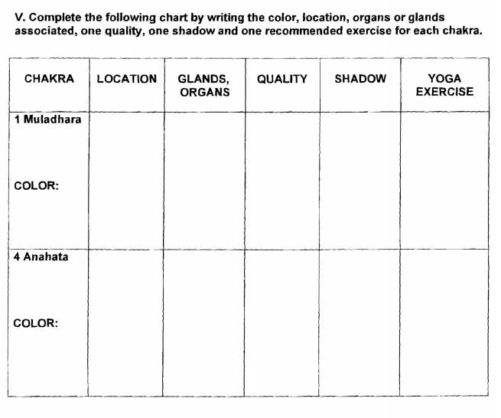

KRI INTERNATIONAL TEACHER TRAINING - LEVEL 1: INSTRUCTOR
Interactive Final Exam / Self-assessment

Name: Date:

MUDRAS
Short exercise, few minutes only.

Give name and at least one benefit of the following mudras. After completion discuss and correct in the small group.
Scoring: each correctly answered part contributes 10% to total score (total score 100% max.) Note the final score.

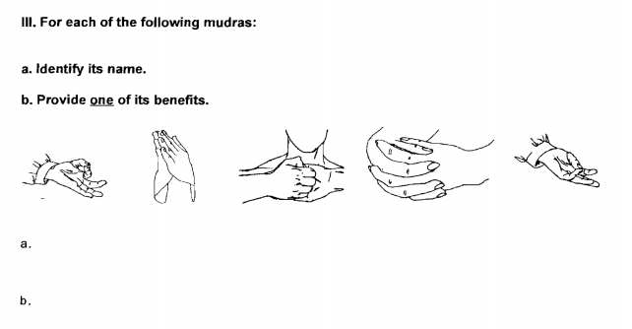

KRI INTERNATIONAL TEACHER TRAINING - LEVEL 1: INSTRUCTOR
Interactive Final Exam / Self-assessment

Name: Date:

MANTRAS
About 5 minutes.

Scoring: each correctly answered mantra contributes 12.5% to total score (total score 100% max.).

Note the final score.

Please give one essential effect of chanting the mantras listed below:

- Sat Nam
Effect:

Har Haray Hari Wahe Guru
Effect:

c. Ek Ong Kar Sat Nam Karta Purkh Nirbhao Nirvair Akal Moorat Ajooni Saibhang Guruprasad Jap Ad Such Jugad Such Haibhee Such Nanak Hosee Bhee Such. Effect:

d. Ra Ma Da Sa Sa Se So Hung:
Effect:

Guru Guru Wahe Guru,Guru Ram Das Guru
Effect:

Chattr Chakkr Varti (Last four lines of Jap Sahib)
Effect:

Sa Ta Na Ma
Effect:

Ad Guray Nameh
Effect:

KRI INTERNATIONAL TEACHER TRAINING - LEVEL 1: INSTRUCTOR
Interactive Final Exam / Self-assessment

Name: Date:

DIET

Match the statements in the two columns.

After completion, discuss and correct in the small group.

Scoring: each correctly answered part contributes 12.5% to total score (total score 100% max.) Note the final score.

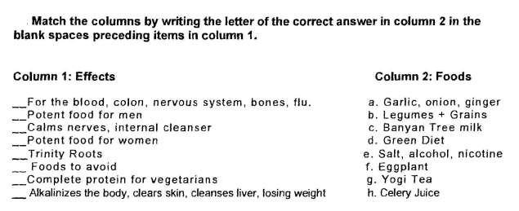

ASANAS
Short exercise, about 3 minutes to complete.

Scoring: each correctly answered part contributes 8.5% to total score (total score 100% max.) Note the final score.

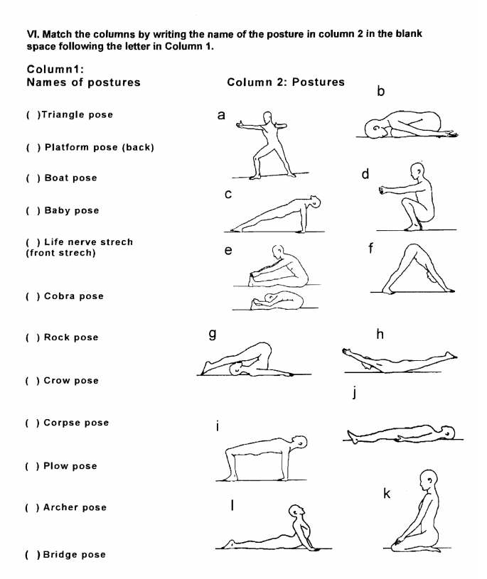

KRI INTERNATIONAL TEACHER TRAINING - LEVEL 1: INSTRUCTOR
Interactive Final Exam / Self-assessment

COMPLETE STATEMENTS
Short exercise, a few minutes only.

Complete the statements by entering the missing information. After completion, discuss and correct in the small group.
Scoring: each correctly answered part contributes 12.5% to total score (total score 100% max.) Note the final score.

Complete the following statements.

- According to yogic science, the human mind works in cycles. We can use various cycles to help replace unwanted patterns of behavior with new, more positive ones. When meditating, it takes …………….. to change a habit, ……………… to confirm the habit, ……………… so that the new habit is who you are and finally ……………… to master the new habit.

- The human being is made up of ten bodies, not only one. The …………………
gives you spiritual royalty and radiance. Its strength makes you courageous in the face of any obstacle. You approach life with an "all or nothing" attitude. If it is underdeveloped you may be afraid of conflict and shy. The key to balancing it is ……………………

- There are two laws for a Kundalini Yoga Teacher. The ……………………. is to deliver the student to the Infinite, not to you. Elevate the student to the awareness of the Infinite within them. The ………………….says that you should KEEP UP! Once you are the representative of a students' higher consciousness, never betray the projection. Be like the Spirit: steady, timeless and trustworthy.

DISCUSSION
Discuss the following statements one-by-one in small groups.

Process:
- read one statement at a time
- take 2-3 minutes for individual reflection
- then share ideas and discuss in the small group Time: About 10 minutes per statement.
Scoring: No score.

Topic 1 - Discussion: Teachers Oath
Write down the Teachers Oath and its meaning for you. Share in your group.

Topic 2 - Discuss your key ethical responsibilities as a teacher of Kundalini Yoga in terms of:

  - Your service to students

  - Your personal conduct

  - As a Kundalini Yoga Teacher one of your responsibilities is to ensure that your class is welcoming and safe for every student. What are the elements that create this safe and welcoming space?

Topics 3-5 - Please explain your understanding of the key concepts below, and how you could you use these ideas in your life. Please write your answers on a separate sheet of paper.

  - What are the signs of Shakti Pad, its gifts?

  - What is a spiritual teacher? How are they similar and how different from coaches, mentors, and other types of teachers? What are the benefits of relating to a spiritual teacher? What are the risks? Do you view yourself as a spiritual teacher? Why or why not?

  - How can I contribute to an alive, safe, inclusive, and vibrant KY community?

