KRI INTERNATIONAL TEACHER TRAINING LEVEL 1: INSTRUCTOR

Interactive F i n a l E x a m

ANSWERED COPY: FOR TEACHER TRAINERS ONLY

QUESTIONS – 1st series (Answers to these questions are not included)

- Explain three main differences between the Piscean Age and the Aquarian Age
(Any of these) Piscean Age: era of machines, hierarchies, goal was to find the right information and access it, God/Guru is outside of us, emphasizes authority and domination, people needed gurus. Motto “I want to know” “to be or not to be” – Great knowledge guarded by Secrecy.
Aquarian Age: era of awareness/information, energy, no secrets, wisdom to discern and choose right information, God is within each of us, emphasizes sensitivity and compassion; life and information flows much faster; people will have psychological & fatigue related illnesses from stimuli overloading the brain; people are their own guru. Motto: “ I know therefore I believe.” And “be to be” - Values embodied in practical action.

- What is Yoga?
Yoga is a relationship. The word comes from “joke” from Sanskrit Jugit – to join together or unite. It means “yoke” or “union”. It is the union of our finite self to the Infinite/the universal ONE.
- Mention three ways in which yoga helps the nervous system
  - Increases capacity for energy flow
  - Increases energy flow (especially via breath of fire)
  - Balances sympathetic and parasympathetic nervous systems
  - Promote brain cell connection, which lead to robust circulation and good glandular balance and helps prevent depression.
  - Can help alleviate chronic pain by increasing the amount of information travelling down a shared neural pathway, effectively diluting the pain information.
  - Meditation w/ eye focus, mudra and chanting aloud actively involve the thalamus.
- What are the main differences between Kundalini Yoga and Hatha Yoga?
Kundalini integrates the 8 limbs of Yoga, Golden Chain, works on the glandular and nervous system, No altering of Kriyas and meditations. It is called the Yoga for householders because it is a quick and practical way to achieve mind/body/spirit health.

Hatha focuses on the physical aspect of Yoga. Teachers do not tune into the Golden Chain or follow prescribed Kriyas.

- How does Kundalini Yoga work?
Concepts of Prana, Apana, Sushmuna and navel point. Prana is the life force of the atom/positive energy. Apana is elimination/eliminating force/negative energy. Both are governed by the ida and pingala. When these two energies join under the power and science of Kundalini Yoga, we mix the prana and apana and bring the Kundalini up through the central nerve or sushmuna to reach the higher chakras. When prana/apana balance they awaken the dormant Kundalini energy at the base of the spine, which rises through the sushumna, activates the pituitary and pineal glands and brings awareness. This is also the process of balancing and strengthening the nervous and glandular systems to keep your body properly regulated.

Kundalini Yoga is the yoga of awareness. It is a science and technology that specifically works on the nervous and glandular systems through angles and triangles of the body to adjust the systems so the energy can flow and we can have an experience of our true Selves. It works through the breath, movement, mantra, mudra and meditation to strengthen and balance the body, clear subconscious patterning so that you can see life clearly/neutrally and have a greater capacity/energy to live it.

- What is the relationship between Kundalini Yoga and Sikh Dharma?

KY Yoga is the technology.
KY Yoga: is not a religion. It is open to all faiths, uses mantras from Sikh Dharma, Golden chain links us to the Sikh Gurus and all masters who came before us, uses kriyas and meditations. The energy of the Raj yoga has come through the house of Guru Ram Das. In the spirit of the Sikh way, all are one. Sikh Dharma gives an example of living the Aquarian consciousness. Kundalini Yoga gives the tools to reach that awareness.

Sikh Dharma: Dhama is an elevated path or lifestyle where humbleness, elegance, grace and be at service for humanity, honest work, etc. are a way to integrate the practice of Kundalini Yoga into a lifestyle. Yogi Bhajan was head of Sikh Dharma in Western world, Sikhism is a religion that views the Siri Guru Granth Sahib as the living teacher of the Sikh faith.

- Who is Yogi Bhajan?
Yogi Bhajan was the Master of Kundalini Yoga. Yogi Bhajan who brought the secret science of Kundalini Yoga to the West in 1969 and spread the teachings worldwide. He began his yoga training at 8 years old and mastered KY Yoga at age 16. He was the Mahan Tantric and head of Sikh Dharma in the west. He founded 3HO and KRI. He started and managed many businesses like 3HO, KRI, Golden Temple Foods, Akal Security, etc. His motto was: “if you can’t see God in all, you can’t see God at all.” His goal was to spread the teachings and make students be ten times greater than himself.

- What is the Golden Chain, and how does Yogi Bhajan fit into it?
The Golden Chain is the connection between all of the masters, gurus, before us and forms a channel for the energy, wisdom, and protection to flow to and through the teacher unto the students. Yogi Bhajan came to carry the message of Guru Ram Das and became the link to the House of GuruRam Das and all the teachers before. The Golden Chain is the legacy of wisdom and teachings that all KY Teachers are contained within and connect to through the Adi Mantra. Their subtle body energy is present when we tune in.

- What is Prana?
With a Capital “P”, prana is the subtle life force. The first unit of energy. Prana is the motion and coding of life energies through the realms of the mind and body.
- What is sadhana? Explain it within the context of aradhana and prabhupati.
Sadhana is a practice of self-discipline that allows one to express the infinite through one’s self. It is a time each day to notice the patterns that lead away from higher consciousness and to transcend those patterns with conscious activity. Sadhana may be difficult when you are starting out but when you connect to the Universal Self in “Aradhana” it becomes a more positive experience. It brings joy even when it requires effort. When your spiritual practice is integrated into every part of your life it becomes “prabhupati” you have mastered the universe and may experience continuous states of meditation. Aquarian Sadhana includes Japji, a Kriya and 7 mantra meditations. By becoming the master of yourself the universe is mastered as well.

QUESTIONS – 2nd series (Answers to these questions are not included)

- Why is the practice of sadhana essential to a Kundalini Yoga Teacher?
Sadhana is one of the first conditions for effectiveness in the teachings. “A teacher who does not have a beam of energy within him or herself cannot teach Kundalini Yoga.” It is absolutely necessary for teachers to do a regular sadhana to improve their radiance and impact. Sadhana develops your presence and projection as a teacher. You need to clear your attachments and subconscious every day, have a potent projection, and control you own inner shadows so you can be a vessel for the teachings and serve others. It connects you to your SAT NAM and infinity so you can help students do the same.

- Mention two basic benefits of doing group sadhana.
Develop group consciousness, receive the support and strength of community, if one person achieves an elevated state of consciousness everyone benefits, the group energy amplifies the effects. When everyone’s energy has intermingled and merged it is easy to communicate and be on the same wavelength. We experience this effect throughout the day. There will be fewer misunderstandings in the area of communication. The meditative mind is the neutral mind that runs your destiny. It is magnetic, attractive, creative and the best way to conduct your destiny. The neutral mind judges and assesses without attachment to your own purpose and reality. It observes the actions of the Negative and positive minds and judges both in relation to your higher self. It gives you the capacity to step back from your emotions and respond vs. react. To stay aligned with our true purpose vs. being a victim of circumstance. The neutral mind makes more discerning decisions that go beyond preferences, judgments, emotions and employs intuition and the infinite. We act from the wisdom of our heart and our soul mission.

- Describe the basic structure of a Kundalini Yoga class
Tune in w/ Adi Mantra, Pranayam and/or warm up, Kriya, Meditation, Relaxation, Closing with Long Time Sun, Long Sat Naams and a prayer/blessing. If possible an opportunity for students to socialize, ask questions and enjoy Yogi Tea. The order of the relaxation and meditation may vary depending on the Kriya.

- Can you teach Kundalini Yoga even if you are not perfect? Explain why or why not.
Yes, many so called “perfect” teachers fail throughout history. “The reason you teach is to be an instrument of the cosmic flow. Anyone who teaches to be a teacher rather than to serve will fall. To be a teacher is the ultimate end.” “Whenever you chant Ong Namo Guru Dev Namo, through the grace and blessing of Guru Ram Das, Bhagvati, the creative power of the universe, God, the Ultimate, the Infinite, dwells in you as a yogi, and that is what you teach.” The Adi Mantra centers us into the higher self and reminds our lower minds that it is not our ego that will practice or teach Kundalini Yoga.

- Name 2 dristis and their benefits
  - At the Third Eye Point (Shambavi Mudra) The Brow Point, the
root of the nose. The sushmuna, the central nadi is stimulated. This stimulates the pituitary; intuition is developed.
  - At the Tip of the Nose (Agiaa Chakra Bandh) This is the highest lock. It is referred to as the Lotus Point Meditation. This controls the mind, which is locked in a triangle. When the optic nerve concentrates at
the tip of the nose, the ida, pingala, then sushmuna achieve a center of balance. This stimulates the pineal gland and the frontal lobe of the brain. New energy pathways are created in the brain patterns.
  - At the Moon Center This is the tip of the chin, with the eyes closed and rolled down. This is cooling, calming. You see yourself clearly.
  - At the Crown Chakra The Tenth Gate; the top of the head. This stimulates the pineal and the crown energy center.
- What is Shakti Pad?
The 3rd stage of development on the Path of Wisdom (Saram pad, Karam pad, Shakti Pad, Sahej Pad, Sat Pad). You are the CRAFTSMAN and have gained experience from various contexts and have a solid foundation. The ego thinks it is much more advanced than it really is and no longer needs the discipline of the first two stages. You withdraw and drop your practice. A false sense of Mastery that makes or breaks the practitioner.

- What is a Pranayam?
Pran is the first unit of life. Prana is the life force. Yama is the expansion. It is the science of expanding the life force through the use of breath. It is the regulation of prana (life force energy) through the breath. Different pranayamas will move the energy in different ways to produce a specific effect. Ex: Breath of fire to regulate the nervous, glandular, lymphatic, respiratory systems through breath.

- How do you teach your students to perform breath of fire?
Sit in easy pose, spine straight, neck lock/chin pulled in. Place on hand on your solar plexus. Breath slowly in and out through the nose. Then increase the pace. Focus on diaphragm breathing: steady and continuous breath in and out of nose; equal ratios of inhale and exhale; to start you can have the tongue out and pant like a dog with the hand on the navel and start at a slower pace. Don’t exaggerate the navel pumping and keep the focus on the third eye. Avoid if pregnant or first days of cycle.

- How do you teach your students to perform long deep breathing?
Long Deep Breathing starts by filling the abdomen; then expanding the chest, and finally lifting the upper ribs and clavicle. The exhale is the reverse: first the upper deflates, then the middle, and finally the abdomen pulls in and up, as the navel point pulls back toward the spine. First, practice by separating the three parts of the breath: ABDOMINAL/LOWER, CHEST/MIDDLE, CLAVICULAR/UPPER. Sit straight on the floor, in a chair, or lie on the back. Initially have the left hand on the belly, right hand on the chest to feel the movement of the diaphragm. Let breath relax at normal pace/depth. Bring attention to navel, breathe slow and deep into belly and expand it with air. As you exhale gently pull navel in and up toward spine, chest relaxed. Then add the Chest Breath and finish with a Clavicular Breath. AIl three are done in a smooth motion. Start the exhale by relaxing the clavicle, then slowly emptying the chest. Finally, pull in the abdomen to force out any remaining air.
Each part of the breath expansion is distinct. If all three are combined, you have a complete Long Deep Breath.

- ln Kundalini Yoga we use several mudras and bhandas, define both of these terms.
Both direct and contain energy. Mudras are seals that use different hand and finger positions. The meridians in the hands and the brain alter the consciousness. Bhandas are locks that tighten different muscles.

QUESTIONS – 3rd series (Answers to these questions are not included)

- Who is Patanjali and what is his main contribution to Yoga?
A yogi in the Classical Epoch who systematized and codified the practices of Yoga into the form we practice today. He gathered and identified the 8 Limbs of Yoga and 105 sutras to guide practice.

- Explain how the science of naad works.
“Naad” means the essence of all sound. It is a science that uses sound and the movement of the tongue. The sound current encodes messages or new patterns of energy to your hypothalamus via the 84 meridians on the roof of your mouth. When the tongue hits these points in a specific rhythm repeatedly, it affects your nervous and glandular system via the hypothalamus- creating chemical changes within the brain. By repeating mantras, the naad vibrates the energy centers in your body in a specific sequence, which shifts your awareness and transmutes the energy/emotion in your body strengthening mental/emotional/energetic groove and weakening old patterns.

- What is Shabd Guru?
“Shabd” means sound that eradicates the ego. “Guru” is the teacher. The primal sound current that uses the naad to dissolve the limitations of the ego and elevate consciousness. It is so focused, specific and powerful that it can act as your teacher bringing you from darkness to light.

- What is meditation?
Meditation is the process of controlling and transcending the waves of the mind, allowing for the flow of radiance from the soul. It is a technique to clear the subconscious by focusing your awareness and developing your neutral mind. There are many styles and approaches including: chanting aloud and silently, different breath patterns, using mudras, dhristi, body positions and even whistling. It connects us to our true highest self through merging with universal divine consciousness. It happens when we quiet the mind, allow thoughts to pass without attaching to them and allowing God/The Infinite to talk to us.

- Mention 3 benefits of meditation
Develops neutral/meditative mind, intuition, and frontal lobe of the forehead, which controls your personality. Clears subconscious and old patterning. Fosters peace, contentment, joy, clarity of mind, mental awareness, and the ability to be present. Resolves core issues of stress producing patterns. Releases reactions and unconscious habits, subconscious fears and blocks. Builds the spontaneous and intuitive link to awareness. Normalizes blood pressure. Develops connectedness one “oneness”, takes us from a finite to an Infinite perception of reality by connecting us to the clarity of the soul. Encourages mastery over transforming emotion to devotion.

- What are the three functional minds and what do they do?
The negative, positive, and neutral minds.
The Negative (or Protective) Mind is given for survival. It is reactive, protective, and searches for potential danger. It is senstive to pain, and it shields you from the forces that may disrupt or destroy. The Positive (or Expansive) Mind searches for pleasure, fulfillment, and possibility in how you can utilize things in your experience. It is constructive, risk taking, and active. The Neutral (or Meditative) Mind is the mind that judges and assesses without attachment in relation to your own purpose and reality. The Neutral Mind ideally observes the input of both the Negative and Positive Minds. It is beyond just weighing the “pros and cons” as presented by the other two functional minds. It asks its own, unique, set of questions, such as, “What will serve my soul in this circumstance? Where does my duty lie? What action can I take that will express my highest self?

- Why is it important to develop a neutral mind?
The neutral mind is the “gateway” to your intuition and the guidance of your soul. It is what connects you to the wisdom of your destiny and higher self. Cultivating the habit to process every thought through all 3 functional minds, ending with the neutral mind (and making decisions from that mind), helps you consciously process your emotions (so you are not ruled by them), learn from your mistakes, and not be unconsciously acting out old patterns that may no longer serve you.

- What is Karma and what is Dharma?
Karma is the realm of cause and effect that is presented to you through life circumstances, family & cultural dynamics, relationships, patterns, your fate vs. destiny, i.e. things that you need to work through. These are opportunities for you to resolve the unresolved and expand. It is created when we act on FATE vs. DESTINY. Every action has a reaction that can hold us back to the wheel of creation, creating and paying karmic debt until we are liberated. Dharma is the path or action that fulfills your highest purpose in this lifetime of living your DESTINY. It is outside of the realm of karma.

- What is Maya?
The veil of illusion and separateness. The illusory reality that is formed based on our attachments, emotions, subconscious impressions and thoughts. It makes us see the world as duality therefore we live in a lie where we think everything is separate and cannot find the truthful connection between all and everything.

- What are the three aspects of GOD according to Yogic Philosophy
Generating, Organizing, Destroying/Delivering forces.

A/B QUESTIONS - Series 1

Scoring: Each A/B Question is 100% if answered correctly. Partially correct answers get a part of that score.

1. Two of the benefits of deep relaxation are:
Any two of these:
Breaks old patterns in muscles and blood flow; we become more sensitive to the energy patterns of life; alters the glandular balance in the blood and the functioning of the brain; rejuvenates the parasympathetic system; allows energies that have been released in the body and mind to circulate and come to equilibrium without the ego as “the director of the show.”

2. Two of the things you must do in order to prepare to teach a Kundalini Yoga class
Any two of these: Take a shower/bath, run fingers under cold water run them through your hair and scalp, comb hair back and forth, cover head, wear white, say the Teacher’s oath, arrive early, prepare the room, tune in.

- Two of the historical influences on our practices and philosophies in Kundalini Yoga are:
Sikhism, tantra, hatha yoga, Baba Virsa Singh, Sant Hazara Singh, vendanta, Ayurveda, Dhirendra Brahmachari, Acharya Narinder Dev of Yoga Smriti, Sant Ranjit Singh, The Udasis, Swami Devmurti

- Two reasons for covering your head are:
(Any two of these:) for his/her personal protection and upliftment when handling the powerful energies involved when teaching a Kundalini Class. Head coverings hold the energy in and offer containment, create a meditative focus point at the brow, give a cranial adjustment, stabilizes the cerebral matter and 26 parts of the brain which are interlocked with the neurological system and electromagnetic field. The 5 to 7 layers of turban cover the temples and prevents the variance or movement in the different parts of the skull giving a cranial self adjustment. It protects crown chakra, increases intuition, and fosters the flow of Kundalini energy rising.

- Two things a teacher can do to prepare the environment for a Kundalini yoga class
(Any two of these:) Quiet the room, clean the space, open the windows, set the temperature, adjust the lights, use uplifting music, prepare yoga mats, add flowers or art, test out sound system, welcome students.

- Why should all students pay for Kundalini Yoga classes?
(Any two of these:) To respect the exchange of energy: “Empty handed you come, empty handed you go” and to continue the flow of prosperity. To benefit from the teachings, preserve the teachings, be grateful for the teachings

- Two essential benefits of Sat Kriya are:
(Any two of these): Balances energy of prana and apana at the navel point helping to raise the Kundalini, Tones the nervous system, creates a physiological balance, blood pressure is maintained evenly, rhythmic contraction and relaxations produces waves of energy that circulate, energize and heal the body, its excellent for digestive troubles and transcending fears, it pulls the lower 3 chakras in unison which multiplies the effects and stabilizes the changes.

- Two things you would do if a new student informed you of back problems before joining your class are:
(Any two of these): Encourage them to listen to their body and modify accordingly, show them a modification, instruct them to avoid being competitive or pushing their bodies aggressively, remind them to engage abdominal muscles, avoid body drops, back bends, anything that puts pressure on the back, instruct them to visualize doing the exercise perfectly, give extra warm ups, remind them to breathe deeply, ask them to check with their doctor about certain exercises.

- Two things you would do if you have beginners and very experienced students in the same class are:
Adjust times for a middle ground, give more instructions for beginners, have handouts/mantra sheets for beginners, demonstrate clearly, watch, guide and inspire. Challenge the experts with more information/nuances of the work.

- Two options for warm-ups before teaching the Kundalini Yoga Kriya are:
(Any two of these) Sufi grind, ego eradicator, miracle bend, stretch pose, pranayama, a short Kriya, sun salutations, spinal flex, cat cow, life nerve stretch.

A/B QUESTIONS - Series 2

Read the following items and answer them briefly on the spaces provided.
- Two of the things one must do when waking up according to yogic lifestyle are:
Any two of these: WAKE UP ROUTINE: On your back, eyes closed bring hands to face and stroke the face, open eyes into the hands, slowly lift hands away adjust eyes to light in the room, massage your face. Stretch arms overhead, point toes. DO A CAT STRETCH.
DO STRETCH POSE. Turn on right side pull knees into chest to strengthen heart. Return to back, pull knees to chest with nose between knees. Lock hands around knees. Do Breath of fire for a minute then roll up into rock pose. Bring forehead down to the bed for a moment, relax, breath normally to eliminate gas. Lie on back, rub palms and soles of feet. Get out of bed. CLEAR MONKEY GLANDS, MASSAGE BODY W/ ALMOND OIL. TAKE COLD SHOWER. SADHANA.

- Two of the benefits of hydrotherapy or ishnaan (cold showers) are:
Any two of these:
Flushes the organs and systems, opens capillaries and delivers fresh blood to organs which triggers the glands to change their secretion, keeps radiant skin, prevent breast cancer, keeps blood chemistry healthy and young, cleanses deposits, fosters a bright mind, energizes us.

- Two reasons for being a vegetarian are:
(Any two of these:) Meat is tamasic and produces uric acid, when an animal dies, its proteins coagulate and auto-putrify as they break down and decay releaseing toxins, the process continues in your colon, vegetables do not do this, meat is acidic and produces uric acid in the blood stream which produces cancer, uric acid is a toxin that makes reaching higher states of meditation harder to reach because it is an irritant in the blood stream, meat is a great source of cholesterol which creates heart disease, hardening of arteries and senility, most animals are fed chemicals and hormones to grow fast which you then ingest, meat takes three days to pass through digestion which is longer than the ideal 18-24 hours, respect for living things, the environment, sustainability.

- Two specific points within the body for concentration during meditation are:
: (Any two of these): Brow Point / Third Eye Point (Shambavi Mudra), Tip of the nose (Agiaa Chakra Bandh), Moon Center/ tip of the chin, Crown Chakra/Tenth Gate.

- One essential effect of
  - Gong meditation is: (Any one of these): creates deep relaxation, releases us from the torrent of thoughts the mind releases, stimulates the glandular system to a higher level of functioning, releases blocks, reduces tension, stimulates circulation, reorganizes the emotional energy and feelings that are tied into the body structure, changes the feelings that are blocked by cutting the thoughts that sustain and recreate feelings.

  - Tratakam meditation is: (Any one of these): increases concentration, focuses pranic energy, experience different facets of your self-experience, a way to experience the qualities of the object of meditation in yourself (ex- a saint’s humility, service and healing), karmas can be erased, if meditated on seriously and properly, individual’s destiny can be expanded, “mental beaming” gives the mind the ability to project to infinity through the creative power of the imagination.

- Two yogic techniques that you could recommend to someone who is struggling with a smoking addiction are:
(Any 2 of these): Kriya for addiction, Kriyas that clean the liver and rebalance the nervous system, Sitali Pranayam, Long deep breathing or any pranayama

- A primary function of the following gland and organ is:
a. Adrenal glands produces: hormones for muscle growth, sex hormones, cortisol (controls carbohydrate metabolism and helps body respond to stress and illness), aldosterone (acts on the kidneys to promote sodium and water retention; adrenaline, responsible for our fight or flight response.
b. Liver Processes all the food nutrients absorbed by the small intestine into useful forms of sugar, fat and protein and eliminate toxins produced and ingested in the body.

- Two yoga exercises that are not recommended for women during menstruation are:
(Any two of these) Exercises that apply pressure to the abdominal area or are over stimulating like bow pose, Breath of fire (Light breath of fire is ok after the first few days), leg lifts, mulbandh, inversions, Sat Kriya.

MULTIPLE CHOICE QUESTIONS

Scoring: Correct=100%, Incorrect=0%

MULTIPLE CHOICE QUESTIONS

- In Kundalini Yoga the most important thing is:
  - To read, study and prepare the intellect
  - To push and proselytize
  - To experience, this can't be replaced by words
  - To develop special powers or siddihs

- In order to enhance the power of mantra you should
  - Know its exact meaning
  - Have rhythm, projection and correct pronunciation
  - Sing i t like a choir with many different harmonies
  - Repeat it until you memorize it

- How do you practice the breath that lowers fevers (Sitali Pranayam)?
  - lnhaling and exhaling through the nose allowing air to come in and out freely
  - lnhaling through the nose in four parts and exhaling through the nose
  - lnhaling through the tongue, curled and extended, and exhaling through the nose
  - lnhaling through the mouth with a high-pitched whistle, exhaling through the nose

- Breathing through the left nostril is associated with:
  - Calmness and sensitivity
  - Vigor and alertness
  - Activating the sun energy in the body
  - Balancing brain hemispheres

- A Kriya in Kundalini Yoga is:
  - Any reflex or action performed during a Kundalini Yoga class
  - Words that are used specially for meditation
  - A sequence of postures, breath and sound with a specific effect
  - Random collection of actions that a teacher puts together for class

- The neck lock or jalandhar achieves
  - Massages the intestines and the heart muscle
  - Blends the prana and the apana
  - Helps the body achieve a perfect healing state
  - Seals the energy generated in the upper areas of the brain

- How do you perform mulbhand?
  - Lifting the chest and sternum upward and stretching the back of the neck straight
  - Pulling the abdominal region in and up and lifting the chest
  - Contracting the anal sphincter, the area around the sex organ and the navel point.
  - Contracting muscles, nerves and organs all at the same time.

- Why is meditation during pregnancy important?
  - The mother gains flexibility by sitting on the floor for long periods of time.
  - The baby will be more resistant to infant diseases
  - The mother will feel less physical pain while giving birth
  - The baby experiences the effects of meditations as if he/she was meditating him/herself

- As a Kundalini Yoga teacher, you should
  - Try to earn as much money as possible from your students
  - Strive to serve the consciousness of each student
  - Cater to the students’ emotional demands so they stay happy and keep coming to class
  - All of the above

- The ideal pace for Sat Kriya is:
  - Whatever is comfortable for you
  - About 10 repetitions in 8 seconds.
  - As fast as you can while still maintaining the form and rhythmic navel movements
  - About 8 repetitions in 10 seconds

- The Nadis are:
- The seven nerve centers of the body located in the spine
- Channels in the body through which the prana flows
- Yogic exercises that have specific benefits
- Vital airs of the body located above and under the navel

- The Tattwas are:
- Air, Water, Fire, Earth and Ether
- Rajas, Tamas, and Satva.
- Saram pad, Karam pad and Shakti pad
- Ida, Pingala and Shushmana

CHAKRAS

CHAKRA | LOCATION | GLANDS, ORGANS | QUALITY | SHADOW | YOGA EXERCISE
1 Muladhara  COLOR:  Red | End of spine between anus and sexual organ | Organs of elimination | Grounded, centered, secure, loyal, stable, healthy functions of elimination | Fear, insecurity, feel life like a burden, weak constitution, elimination problems, feeling of not belonging | Crow pose, chair pose frog pose, body drops, mulbhand, front stretches, lying on the stomach, feet kicking buttocks
4 Anahata  COLOR:  Green | Middle of the chest on the breast bone at the level of the nipples | Heart, lungs, thymus | Kindness, Compassion forgiveness, service, love, awakening to spiritual awareness | Grief, attachment, close to surrounding s, easily hurt, dependent on love and affection from others, fear of rejection | Ego eradicator, bear grip, baby pose, arm exercises, all pranayam, exercises which twist the upper torso

MUDRAS

- Identify its name.
- Provide one of its benefits.

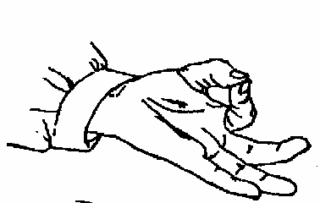 | 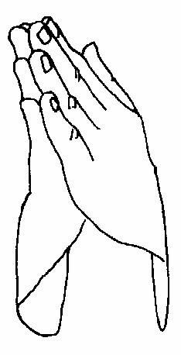 | 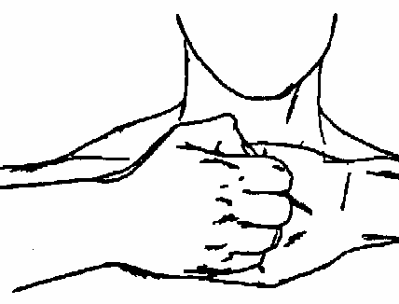 | 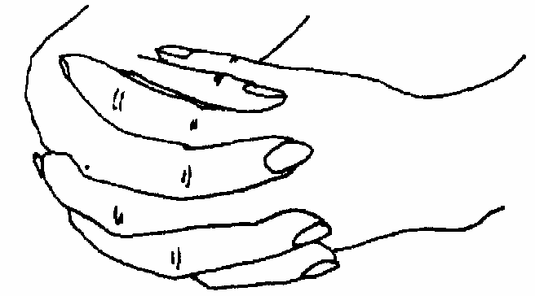 | 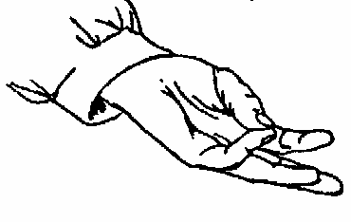
- Gyan Mudra | Pranam or Prayer Mudra | Bear Grip | Venus Lock | Buddhi Mudra
- Receptivity, calmness,  knowledge and ability. | Neutralization of positive and negative sides of the body, centers one self. | Stimulates heart and intensifies concentration | Canalizes sexual energy, promotes glandular balance, concentration | Clear and intuitive communication

MANTRAS

Please give one essential effect of chanting the mantras listed below:

- Sat Nam
Effect: Awakens the soul, gives you your own destiny, balances the five elements ( tattwas)

- Har Haray Hari Wahe Guru
Effect: It can bring you through any block in life

- Ek Ong Kar Sat Nam Karta Purkh Nirbhao Nirvair Akal Moorat Ajooni Saibhang Guruprasad Jap Ad Such Jugad Such Haibhee Such Nanak Hosee Bhee Such.

Effect: The highest of all mantras. Acts as a compass towards God, it forms the basis of the consciousness of our very soul.

- Ra Ma Da Sa Sa Se So Hung:
Effect: For healing yourself and others. Brings balance

- Healthy am I, Happy am I, Holy am I
Effect: mantra in English that works as a positive affirmation

- Chattr Chakkr Varti (Last four lines of Jap Sahib)
Effect: Removes fear, anxiety, depression, and phobias, brings victory.

- Sa Ta Na Ma
Effect: Effect: Catalyst for change, cleans the mind.
- Ad Guray Name
Effect: clears the clouds of doubt and opens us to guidance and protection. It surrounds the magnetic field with protective light

DIET

Column 1: Effects Column 2: Foods

g. For the blood, colon, nervous system, bones, flu. a. Garlic, onion, ginger
c. Potent food for men b. Legumes + Grains
h. Calms nerves, internal cleanser c. Banyan Tree milk
f. Potent food for women d. Green Diet
a. Trinity Roots e. Salt, alcohol, nicotine
e. Foods to avoid f. Eggplant
b. Complete protein for vegetarians g. Yogi Tea
d. Alkalinizes the body, clears skin, cleanses liver, losing weight h. Celery Juice

ASANAS

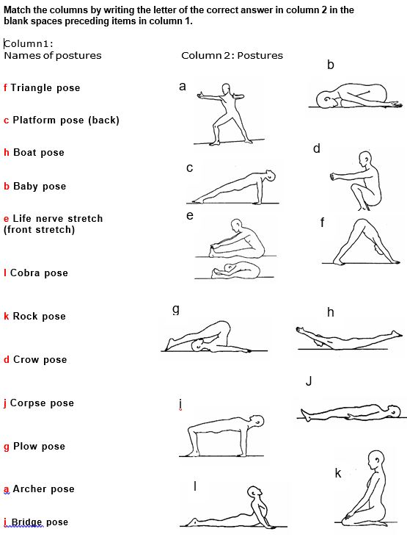

Complete the following statements.

- According to yogic science, the human mind works in cycles. We can use various cycles to help replace unwanted patterns of behavior with new, more positive ones. When meditating, it takes 40 days to change a habit 90 days to confirm the habit, 120 days so that the new habit is who you are and finally 1000 days to master the new habit.

- The human being is made up of ten bodies, not only one. The Radiant Body, 10th body Gives you spiritual royalty and radiance. It’s strength makes you courageous in the face of any obstacle. You approach life with an “all or nothing” attitude. If it is underdeveloped you may be afraid of conflict and shy. The key to balancing it’s commitment, do not cut the hair

- There are two laws for a Kundalini Yoga Teacher. The Law of Deliverance is to deliver the student to the Infinite, not to you. Elevate the student to the awareness of the Infinite within them. The Law of Sustenance says that you should KEEP UP! Once you are in the representative of a student’s higher consciousness, never betray the projection. Be like the Spirit: steady, timeless and trustworthy.

DISCUSSION
Discuss the following statements one-by-one in small groups.

Process:
- read one statement at a time
- take 2-3 minutes for individual reflection
- then share ideas and discuss in the small group Time: About 10 minutes per statement.
Scoring: No score.

Topic 1 - Discussion: Teachers Oath
Write down the Teachers Oath and its meaning for you. Share in your group.

Topic 2 - Discuss your key ethical responsibilities as a teacher of Kundalini Yoga in terms of:

  - Your service to students

  - Your personal conduct

  - As a Kundalini Yoga Teacher one of your responsibilities is to ensure that your class is welcoming and safe for every student. What are the elements that create this safe and welcoming space?

Topics 3-5 - Please explain your understanding of the key concepts below, and how you could you use these ideas in your life. Please write your answers on a separate sheet of paper.

  - What are the signs of Shakti Pad, its gifts?

  - What is a spiritual teacher? How are they similar and how different from coaches, mentors, and other types of teachers? What are the benefits of relating to a spiritual teacher? What are the risks? Do you view yourself as a spiritual teacher? Why or why not?

  - How can I contribute to an alive, safe, inclusive, and vibrant KY community?

